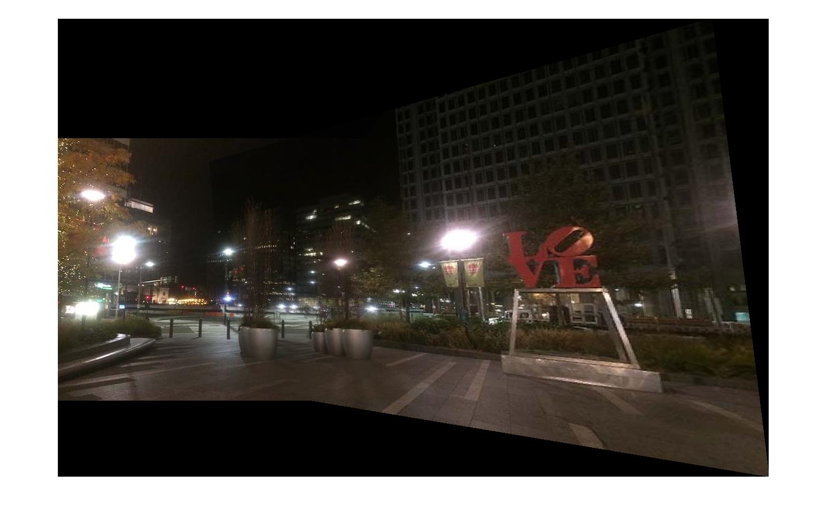

Figure 1: Final stitched mosaic

*Note: Third party code used were corner_detector.m, gaussfilt.m, derivative5.m, and nonmaxsuppts.m.*